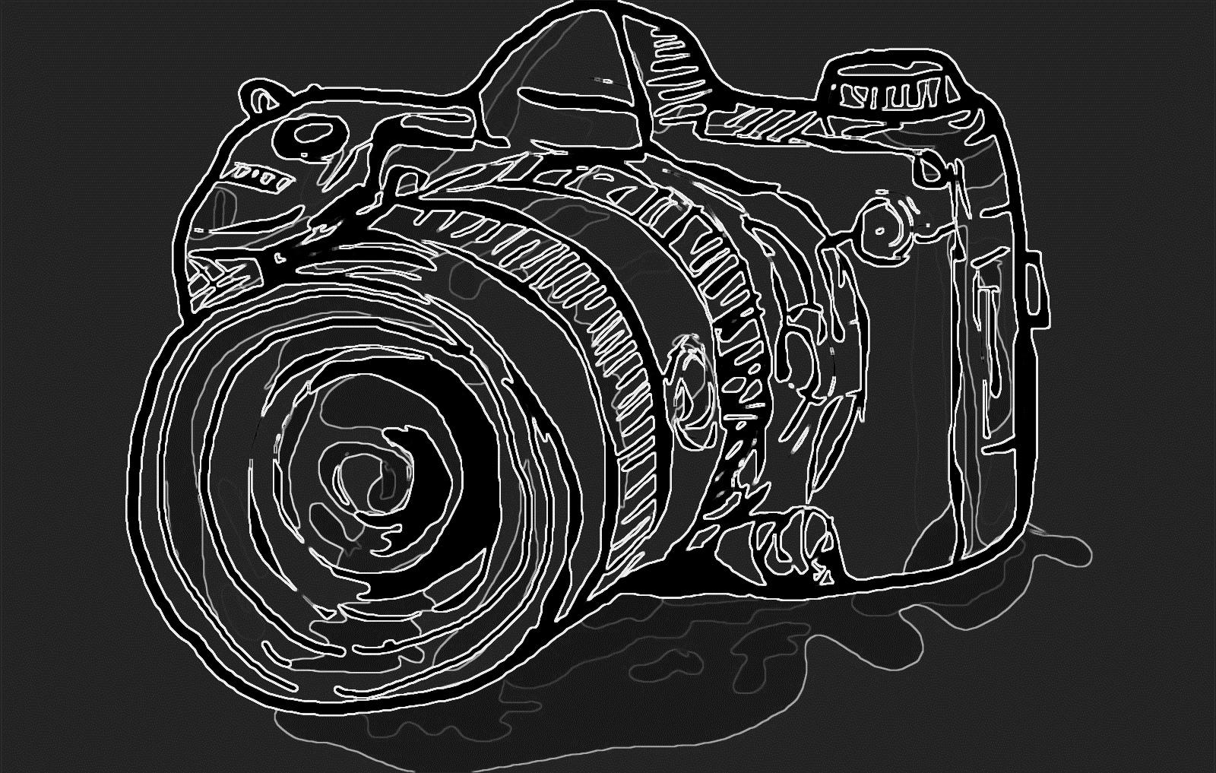
PHOTOGRAPHY SHOWCASE
December 2018 Meade Public Library 104 E. West Plains, Meade, KS

Featuring the work of : JAMES CLAASSEN

